## Programming Concepts Week 8 **Credit** Submission Tasks Template

Student ID: ____103055993_________________

Student Name: ________Mario Stavreski______________________

## Credit Task 11 HTML code

Paste the HTML code of the web page here.

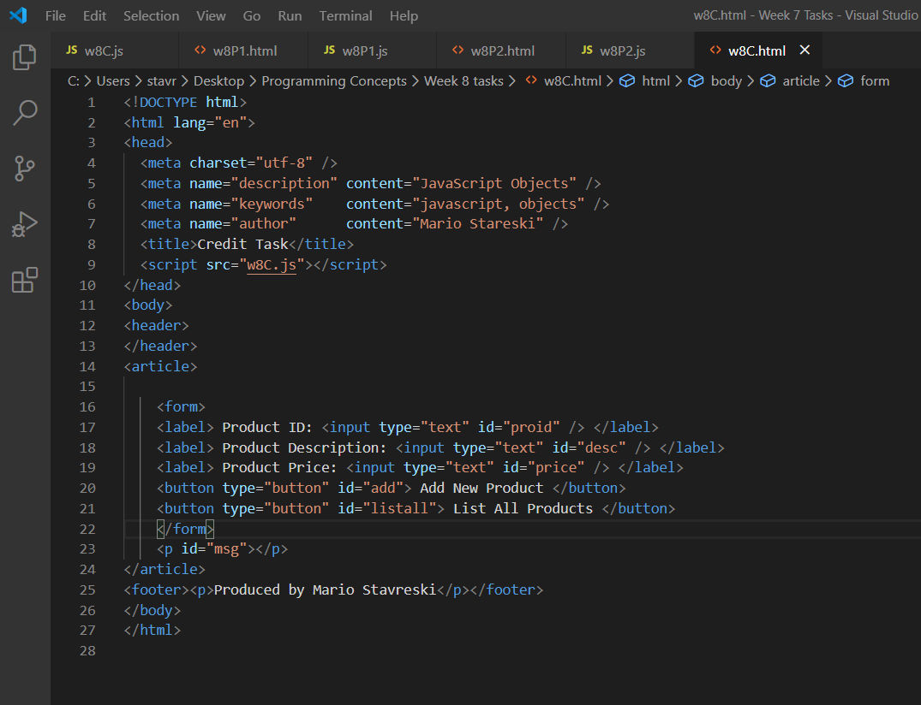

## Credit Task 11 JavaScript code

Paste the JavaScript code of the same page here.

## Credit Task 11 web page testing

Paste the screen captures of your testing web page here.

